CREDIT CARD FRAUD DETECTION
USING MACHINE LEARNING
Expanded Technical Project Report
Submitted by
JEMIMA HOSSAIN
Class XII, Science

Under the supervision of
Dr. Debaditya Barman
Assistant Professor
Department of Computer and System Sciences
Visva-Bharati University, West Bengal, India
Prepared from the project's own report and implementation details

Contents
01 Executive Overview
02 Project Background & Objective
03 System Architecture
04 Project Structure
05 Dataset & Feature Preparation
06 Machine-Learning Methodology
07 Model Configuration & Threshold
08 Streamlit Dashboard — User Journey
09 Dataset Upload — What Happens Step by Step
10 Single Transaction Prediction
11 Batch Prediction & Large Files
12 FastAPI Backend
13 Risk Engine & Business Decision
14 Analytics, SQLite & Monitoring
15 Model Evaluation & Demonstration
16 How I Run the Project
17 Limitations & Practical Considerations
18 Future Improvements
19 Final Summary

01 — Executive Overview
I built this project as an end-to-end credit-card fraud detection application. The machinelearning model is only one part of it. I also built the API layer, dashboard, risk logic, batch workflow, audit history and monitoring view so the project can be demonstrated as a complete software system.

The user's main experience is intentionally simple: upload a dataset or enter a transaction, choose what to analyse, and receive a probability, classification, risk level and business decision. Behind that screen, Streamlit prepares the data, FastAPI performs model inference, and the dashboard turns the response into a readable result.
The delivered package contains the trained model and scaler, model metadata, FastAPI application, Streamlit dashboard, notebook, dependencies, Docker configuration and project documentation .

02 — Project Background & Objective
Credit-card fraud detection is an imbalanced classification problem: legitimate transactions are much more common than fraudulent transactions. That means a model can achieve high overall accuracy while still missing important fraud cases. I therefore use probability, precision/recall-oriented evaluation and a decision threshold rather than relying on accuracy alone.

My objective was to make the model usable outside the notebook. I wanted a buyer or evaluator to be able to start the application, upload a CSV, select a transaction, run a prediction, analyse a complete file and inspect previous results.

The project is therefore split into four practical layers:
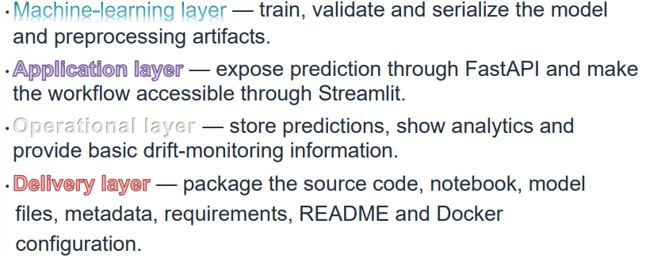

03 — System Architecture
I kept the architecture modular so each part has a clear responsibility. Streamlit handles interaction. FastAPI handles inference. The model artifacts handle prediction. SQLite stores the prediction history used by analytics.
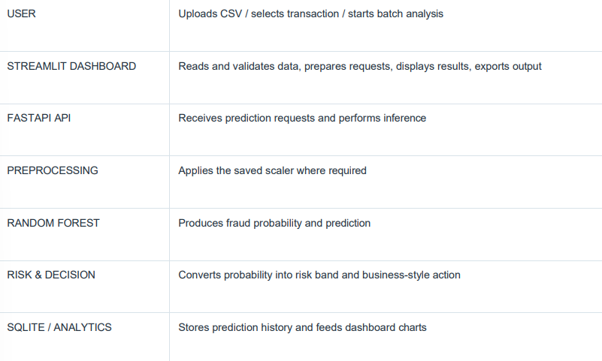

04 — Project Structure

The delivered project is organised so that the code, model artifacts and documentation are easy to identify.
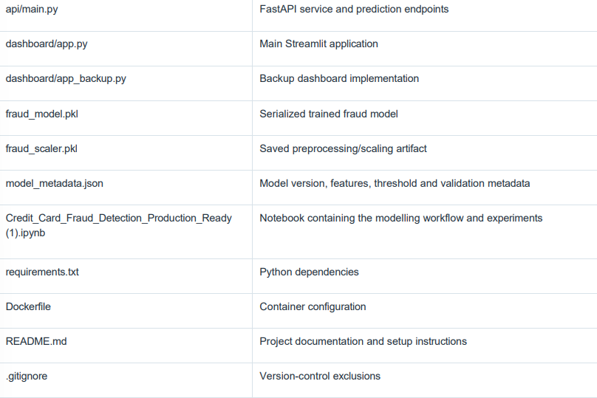

05 — Dataset & Feature Preparation
The application is designed around the standard anonymized credit-card transaction dataset. The model input contains 30 features: Time, V1 through V28, and Amount. The target label is Class, where 0 represents a legitimate transaction and 1 represents a fraudulent transaction.
For dataset-based testing, I use the Class value to let the user filter for normal or fraud samples. The selected transaction number is simply the row/sample selection shown by the dashboard; it is not a permanent banking transaction ID.
Before prediction, I keep the model feature columns separate from the target label.
The Class column is useful for comparison during testing, but it is not supplied as an
input feature to the model.
For a CSV upload, my first responsibility is validation: I check that the expected columns exist before I attempt inference. This prevents a malformed file from silently producing a meaningless prediction.

06 — Machine-Learning Methodology
The notebook is where I developed and compared the machine-learning approaches. The delivered application uses the serialized Random Forest model. The modelling workflow is built around a chronological train/validation/test split rather than randomly mixing all transaction timestamps.

The reason I pay attention to the split and metrics is the class imbalance. In fraud detection, missing fraud can be costly, but excessive false positives can also create operational problems. A useful system therefore needs a threshold and business policy in addition to the raw model

Modelling flow is :
- Load and inspect the transaction dataset.
- Separate input features and the Class target.
- Use chronological train/validation/test partitions.
- Train and compare candidate models in the notebook.
- Select and serialize the delivered model.
- Save preprocessing and metadata alongside the model.
- Expose the trained artifact through the FastAPI service.

07 — Model Configuration & Threshold
The delivered model metadata identifies Random Forest as the selected model and specifies a decision threshold of 0.14. I use that value in the application instead of treating 0.50 as an automatic fraud threshold.

MODEL RANDOM FOREST

Input features 30

Decision threshold 0.14

Split 70% / 15% / 15% chronological

SMOTE Not used in delivered model
I then add a separate risk layer so a probability becomes something a non- technical user can understand.

08 — Streamlit Dashboard: User Journey
Streamlit is the part of the project the user interacts with. I use it as the front-end because it lets me turn the Python workflow into a practical dashboard without building a separate JavaScript application.
The dashboard is organised around the actual tasks I want a user to perform:
- Check model and API status.
- Upload a dataset for testing.
- Select a transaction and run an individual prediction.
- Run batch analysis on a large CSV.
- View the prediction result and risk decision.
- Inspect historical prediction analytics.
- Review basic model-monitoring / drift information .
The important point is that Streamlit is not the model itself. It is the interface and orchestration layer. The prediction calculation is handled by FastAPI using the saved model artifacts.

09 — Dataset Upload: Exactly What Happens

This is the end-to-end flow I would explain to a when demonstrating the project.
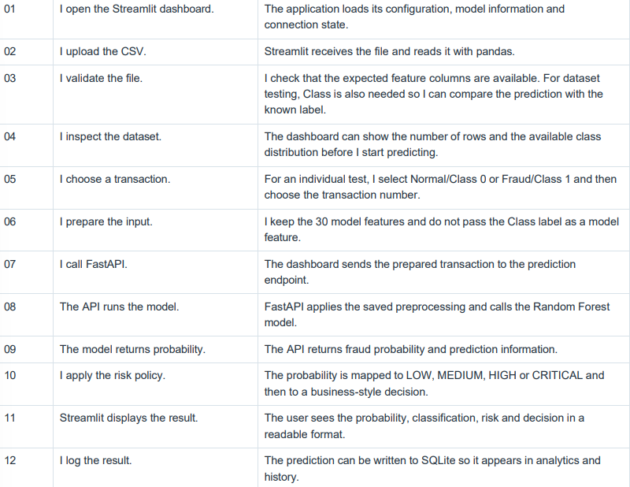

10 — Single Transaction Prediction
For an individual prediction, I want the user to understand one transaction from input to decision. The dashboard therefore shows the selected transaction context and the returned model result rather than exposing raw Python output. 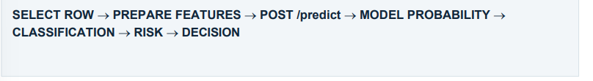

A demonstrated transaction labelled Class 1 produced approximately 99.99% fraud probability, was classified as FRAUD, received CRITICAL risk and resulted in BLOCK / INVESTIGATE. The prediction matched the known Class label for that demonstration.
I treat this as a demonstration result only. A single transaction being correctly classified does not establish overall model performance.

11 — Batch Prediction & Large Files
- When I have many transactions, I do not want one enormous
request to travel from the browser to the API. The batch workflow is therefore designed around chunks.
- The application sends batches of 2,000 transactions to the FastAPI
batch endpoint. The API supports requests up to 5,000 transactions and performs vectorized inference, with model inference handled in internal batches of 2,000.
- The dashboard shows progress as the chunks are completed. After all responses return, the application adds fields such as Fraud_Probability, Prediction, Classification, Risk_Level and Decision to the data and provides the resulting dataset for download .

This is important for practical reliability because a large CSV can otherwise create a single long-running HTTP request and increase the risk of a timeout.

12 — FastAPI Backend
I separated the API from the Streamlit interface so prediction logic is reusable and independently testable. The dashboard can call the API, but the API does not depend on the dashboard being open to perform inference.
The project exposes the following logical endpoints:
- GET /health — check that the service is running.
- GET /model-info — inspect model configuration and metadata.
- POST /predict — predict one transaction.
- POST /predict/batch — predict multiple transactions.
- GET /example — provide an example request.
A typical single prediction request contains the transaction's model features. The API loads the saved model/scaler, performs preprocessing and returns structured prediction information that Streamlit can render.
This separation is also useful for future deployment because the API can later be placed behind authentication, HTTPS, a gateway or another client application.
Credit Card Fraud Detection API - Swagger UI

13 — Risk Engine & Business Decision
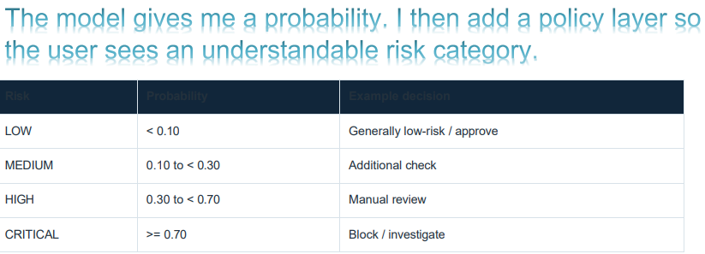
The application decision threshold is 0.14. That threshold is separate from the four risk
bands. Classification and risk communication are related, but they are not the same
calculation.

14 — Analytics, SQLite & Monitoring
I wanted the dashboard to show more than the latest prediction. For that reason, the application records prediction information in a local SQLite database.
The stored information can include timestamp, source, transaction time, amount, fraud probability, prediction, classification, risk level, decision, model name, model version and threshold. The analytics page can then summarise prediction history.

The dashboard also includes model-monitoring functionality based on Population Stability Index (PSI). I use PSI as a signal that the distribution of incoming features may have shifted relative to a reference distribution .

I would not describe PSI as proof that a model is accurate. In a real deployment I would combine drift signals with newly labelled outcomes, precision/recall monitoring and operational review.

15 — Model Evaluation & Demonstration
The notebook's selected Random Forest run reports the following test metrics for that experiment:
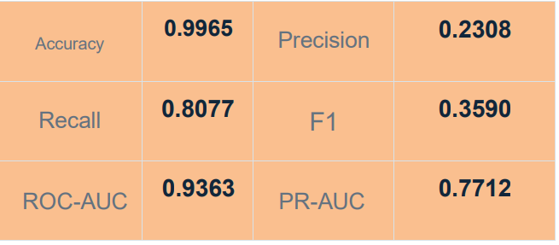
For this problem, I consider precision, recall and PR-AUC particularly important because the dataset is highly imbalanced. Accuracy alone would not tell the whole story .

The notebook also contains experimentation with other thresholds and models. The delivered application uses the 0.14 threshold recorded in the model metadata.
Demonstration result: a known Class 1 transaction returned approximately 99.99% fraud probability, CRITICAL risk and BLOCK / INVESTIGATE, matching the known label.

16 — How I Run the Project
I start the backend first and then launch the Streamlit dashboard.
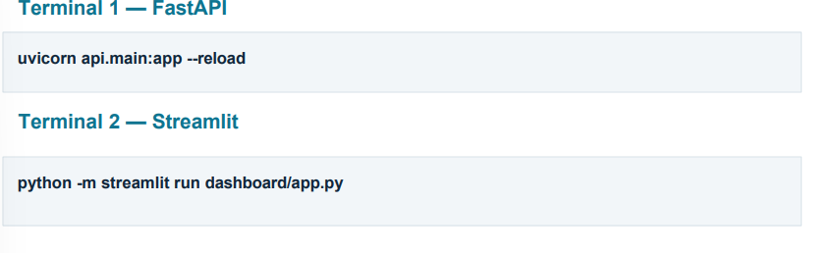
Once Streamlit opens, I check the API connection indicator. Then I normally start with a single transaction test before moving to a large batch. This makes it easy to identify whether a problem is with the service connection, the input file or the batch size.
The repository also contains a Dockerfile. The current container configuration is associated with the backend entry point; for a full production deployment I would normally run the API and Streamlit as separate services .

17 — Limitations & Practical Considerations
- This is an educational/portfolio-oriented fraud-detection prototype, not a live banking payment gateway.
- The V1–V28 features are anonymized, so the model cannot directly explain business fields such as merchant category from the dataset alone.
- The 0.14 threshold is a model-policy setting and should be recalibrated using real business costs before financial production use.
- Real deployment would need authentication, HTTPS, secrets management, stronger validation and operational observability.
- SQLite is appropriate for a local demonstration but not the ideal multi-user production database.
- PSI drift monitoring is only a signal; it does not replace evaluation on newly labelled transactions.
- Serialized model files should be managed with model versioning and controlled deployment in a production lifecycle.

18 — Future Improvements
If I continue this project beyond the delivered version, these are the improvements I would make first:
- Deploy FastAPI and Streamlit as separate services with HTTPS.
- Add authentication and role-based access for the dashboard/API.
- Replace local SQLite with PostgreSQL or another managed database for multi-user use.
- Create a formal model registry and automated retraining pipeline.
- Calibrate the decision threshold from a real fraud-loss / false-positive cost matrix.
- Add SHAP or another explainability layer for transaction-level reasoning.
- Add automated tests for API responses, validation and batch processing.
- Add CI/CD and automated deployment.
- Monitor precision, recall and drift using newly labelled production outcomes.

19 — Final Summary
- 1. The main result of this project is a complete workflow around a machine-learning model. I started with the modelling work, then connected it to FastAPI, and finally built the Streamlit dashboard that a user can actually operate.
- 2. When I upload a dataset, the application reads it, validates the expected structure, lets me choose a transaction or start batch processing, sends prediction work to the API, receives a fraud probability, applies the threshold and risk policy, displays the result and records the prediction for later analytics.

-That is the part I would demonstrate first to a buyer: the project is not just a .pkl file or a notebook. It is an integrated ML application with a user interface, API layer, batch workflow, decision layer, logging and monitorin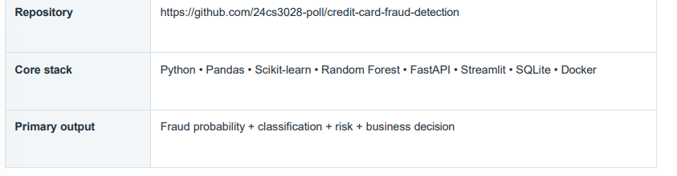

20. Additional Technical Report and Supporting Chapters
The following section continues with the detailed scope note, chapters, implementation details, findings, references and declaration.

Contents
- Chapter 1: Abstract
- Chapter 2: Introduction and Need for Fraud Detection
- Chapter 3: Credit Card Fraud
- Chapter 4: Problem Statement and System Diagrams
- Chapter 5: Objectives of the Project
- Chapter 6: Dataset and Feature Understanding
- Chapter 7: System Design and Workflow
- Chapter 8: Data Preparation
- Chapter 9: Machine Learning Methodology
- Chapter 10: Random Forest Implementation
- Chapter 11: Model Configuration and Threshold
- Chapter 12: Application Implementation
- Chapter 13: Evaluation and Performance Analysis
- Chapter 14: Limitations of the Study
- Chapter 15: Findings and Conclusions
- Chapter 16: Future Scope and Recommendations
- Chapter 17: Project Reflection and Evaluation
- Chapter 18: References
- Chapter 19: Declaration

Chapter 1: Abstract
The increasing use of digital payments and online financial services has made credit-card fraud detection an important application of machine learning. A fraud detection system must distinguish potentially fraudulent transactions from legitimate transactions while avoiding unnecessary disruption to genuine customers. This is challenging because fraudulent transactions are uncommon and the cost of missing a fraudulent transaction can be high.
This project develops an end-to-end credit-card fraud detection application using a trained Random Forest classifier. The system accepts transaction features, produces a fraud probability, applies a configurable decision threshold, and presents the result through a Streamlit dashboard. A FastAPI service exposes prediction functionality to other software. SQLite can be used to maintain prediction audit records, while monitoring tools help identify changes in incoming data. Docker configuration supports a more reproducible deployment.
The project combines machine learning with application development so that the trained model can be demonstrated through single-transaction prediction and batch CSV analysis. The system is intended as a prototype and educational demonstration; it is not a substitute for a bank's production fraud platform, human investigation, or regulatory controls.

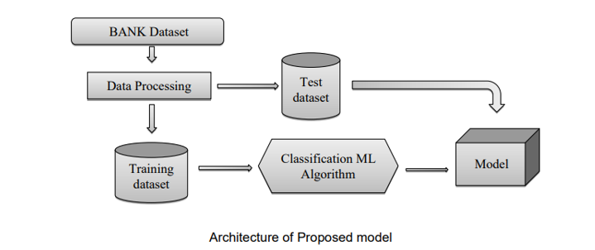

Chapter 2: Introduction and Need for Credit Card Fraud Detection

2.1 Introduction
Credit cards support fast payments in physical stores, websites, and mobile applications. The convenience of digital transactions also creates opportunities for unauthorized use of card information. Fraud detection systems examine transaction signals and estimate whether an activity is suspicious so that it can be reviewed or blocked according to an institution's policy.

2.2 Need for Credit Card Fraud Detection
Manual review alone is not practical when large numbers of transactions occur continuously. An automated model can score transactions consistently, help prioritize suspicious cases, and support analysts in focusing on transactions that may need additional verification. Because fraud is rare, evaluation must consider precision, recall, false positives, and false negatives rather than accuracy alone.



2.3 Scope of the Project
The project covers data preparation, model inference, a browser-based dashboard, API access, batch prediction, prediction logging, basic monitoring, and deployment configuration. The system is evaluated using the supplied project's own dataset and saved model artifacts. It does not connect to a real bank, payment gateway, or live card network.

2.4. LITERATURE SURVEY:
General
A literature review is a body of text that aims to review the critical points of current knowledge on and/or methodological approaches to a particular topic. It is secondary sources and discuss published information in a particular subject area and sometimes information in a particular subject area within a certain time period. Its ultimate goal is to bring the reader up to date with current literature on a topic and forms the basis for another goal, such as future research that may be needed in the area and precedes a research proposal and may be just a simple summary of sources. Usually, it has an organizational pattern and combines both summary and synthesis. It might give a new interpretation of old material or combine new with old interpretations or it might trace the intellectual progression of the field, including major debates. A summary is a recap of important information about the source, but a synthesis is a re-organization, reshuffling of information.

Review of Literature Survey
Title: An Efficient Techniques for Fraudulent detection in Credit Card Dataset: A Comprehensive study
Author: Akanksha Bansal and Hitendra Garg
Year: 2021
Now a day, credit card transaction is one the famous mode for financial transaction. Increasing trends of financial transactions through credit cards also invite fraud activities that involve the loss of billions of dollars globally. It is also been observed that fraudulent transactions have increased by 35% from 2018. A huge amount of transaction data is available to analyze the fraud detection activities that require analysis of behavior/abnormalities in the transaction dataset to detect and ignore the undesirable action of the suspected person. The proposed paper lists a compressive summary of various techniques for the classification of fraud transactions from the various datasets to alert the user for such transactions. In the last decades, online transactions are growing rapidly and the most common tool for financial transactions. The increasing growth of online transactions also increases threats. Therefore, in keeping in mind the security issue, nature, an anomaly in the credit card transaction, the proposed work represents the summary of various strategies applied to identify the abnormal transaction in the dataset of credit card transaction datasets. This dataset contains a mix of normal and fraud transactions; this proposed work classifies and summarizes the various classification methods to classify the transactions using various Machine Learning-based classifiers. The efficiency of the method depends on the dataset and classifier used. The proposed summary will be beneficial to the banker, credit card user, and researcher to analyze to prevent credit card frauds. The future scope of this credit card fraud detection is to explore the things in each and every associations and banks to live safe and happily life. The data must be balanced in each place and we are getting the best results.

Chapter 3: Credit Card Fraud

3.1 Introduction
Credit-card fraud is the unauthorized use of card details or a payment account to obtain goods, services, or money.

3.2 What Is Credit Card Fraud?
In a binary classification setting, a transaction label commonly represents legitimate activity as class 0 and fraudulent activity as class 1. The model estimates how likely a transaction is to belong to the fraud class.



3.3 Types of Credit Card Fraud
- Lost or stolen card fraud: a physical card is used by someone other than its owner.
- Card-not-present fraud: stolen card details are used online or by telephone.
- Counterfeit or cloned card fraud: card information is copied to create an unauthorized payment instrument.
- Account takeover: an attacker gains access to an existing cardholder account.
- Application or identity fraud: false or stolen identity details are used to obtain a financial account.

3.4 Causes of Credit Card Fraud
Common contributing factors include phishing, data breaches, weak authentication, stolen devices, social engineering, compromised merchant systems, and reuse of exposed credentials.
- Growth of online shopping and digital payment platforms.
- Phishing emails and fake banking websites.
- Malware attacks and keyloggers.
- Data breaches exposing customer financial information.
- Weak authentication mechanisms.
- Loss or theft of physical credit cards.
- Social engineering attacks.
- Insider threats within financial organizations.

3.5 Challenges in Fraud Detection
Fraud patterns change over time, legitimate and fraudulent transactions may look similar, and delayed labels can make it difficult to evaluate recent predictions immediately.
Highly Imbalanced Dataset
Fraudulent transactions represent only a very small fraction of all transactions. In the dataset used for this project, only 492 transactions out of 284,807 are fraudulent. This severe imbalance makes model training difficult because the majority class dominates the learning process.
Evolving Fraud Patterns
Fraudsters continuously modify their techniques to bypass existing security mechanisms. Machine learning models must therefore be capable of adapting to new fraud patterns over time.
Real-Time Processing Requirements
Banks process thousands of transactions every second. Fraud detection systems must analyse transactions almost instantly without affecting transaction speed.
False Positives
Incorrectly classifying a legitimate transaction as fraudulent may inconvenience customers by blocking genuine purchases. Therefore, minimizing false positives is important for maintaining customer satisfaction.

False Negatives
Failure to detect a fraudulent transaction may result in direct financial loss. Reducing false negatives is equally important because undetected fraud can significantly impact financial institutions.

3.6 Traditional Fraud Detection Techniques
Traditional systems often use fixed rules, transaction limits, blocked lists, location checks, and expert-defined patterns. These rules are useful but may be rigid and can generate false alarms when customer behaviour changes.
Some common traditional techniques include:
- Rule-based systems
- Manual transaction verification
- Blacklist checking
- Threshold-based detection
- Expert systems

3.7 Machine Learning in Fraud Detection
Machine learning models learn statistical relationships from labelled examples. A classifier can combine many transaction features and output a probability-like score that supports a decision threshold or a risk-ranking workflow.
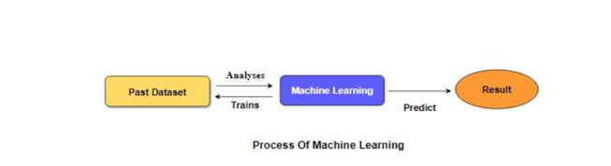

3.8 Impact of Credit Card Fraud
Impact on Customers
- Financial loss
- Temporary account suspension
- Loss of trust in digital payments
- Privacy concerns
Impact on Banks
- Financial reimbursement costs
- Increased fraud investigation expenses
- Reputation damage
- Regulatory compliance challenges
Impact on Merchants
- Chargebacks
- Revenue loss
- Customer dissatisfaction
- Operational overhead

3.9 Need for Intelligent Fraud Detection Systems
An intelligent system can combine automated scoring with thresholds, dashboards, history, and monitoring. It should assist decision-making rather than be treated as infallible.

3.10 Chapter Summary
Fraud detection is a classification and risk-management problem. The system in this project demonstrates how a trained model can be placed inside a usable software workflow.
Credit card fraud has become a major challenge due to the increasing use of digital payment systems and evolving cyber threats. Traditional rule-based systems are no longer sufficient to detect sophisticated fraud patterns effectively. Machine learning techniques provide a robust and intelligent approach by learning from historical transaction data and identifying suspicious activities with high accuracy. Understanding the nature of credit card fraud, its various types, associated challenges, and the role of machine learning provides the necessary foundation for developing an effective fraud detection system. The following chapter presents the problem statement and objectives of the proposed project.
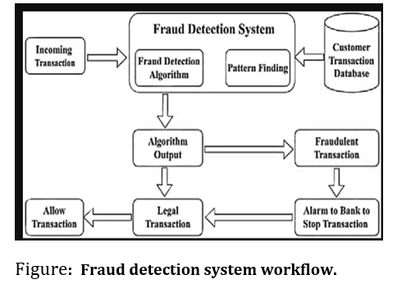

Chapter 4: Problem Statement and System Diagrams

4.1 Problem Statement
The problem is to build a software prototype that receives transaction attributes and identifies transactions that may be fraudulent. The solution should make the prediction understandable to a user, support multiple transactions through CSV upload, and provide an interface through which other applications can request predictions.

4.2 Proposed Solution
A trained Random Forest model is loaded with its preprocessing scaler and metadata. The system prepares inputs, obtains a fraud score, applies the configured threshold, and displays a classification, risk level, and suggested action.

4.3 System Diagrams
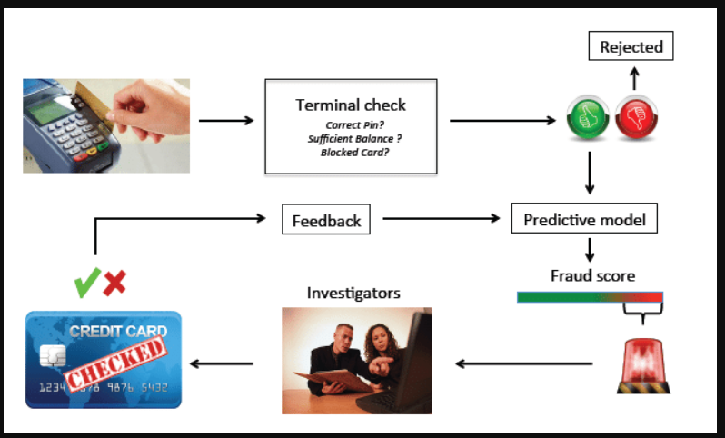

Figure 4.1. System architecture diagram adapted from the supplied report.

Overall workflow:
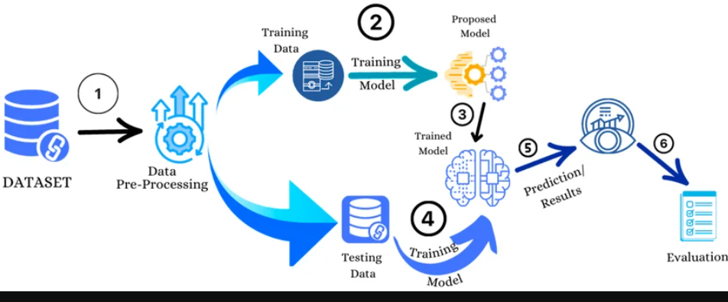

Figure 4.2. Data-processing workflow diagram from the supplied report.

Transaction / CSV → Streamlit Dashboard or API Client → FastAPI / Prediction Pipeline → Random Forest Model → Probability → Threshold → Result → Audit Log / Analytics

Main components:
- Streamlit: user-facing forms, CSV upload, results, charts, and downloads.
- FastAPI: programmatic access to model inference through HTTP endpoints.
- Random Forest: produces a fraud score from the prepared transaction features.
- Scaler and metadata: maintain preprocessing and threshold configuration.
- SQLite: stores prediction history when audit logging is enabled.
- Monitoring: compares incoming feature distributions with a reference distribution.
- Docker: packages the application and dependencies for repeatable execution.

Chapter 5: Objectives of the Project

5.1 Primary Objective
To implement an accessible credit-card fraud prediction prototype using machine learning and a practical application interface.
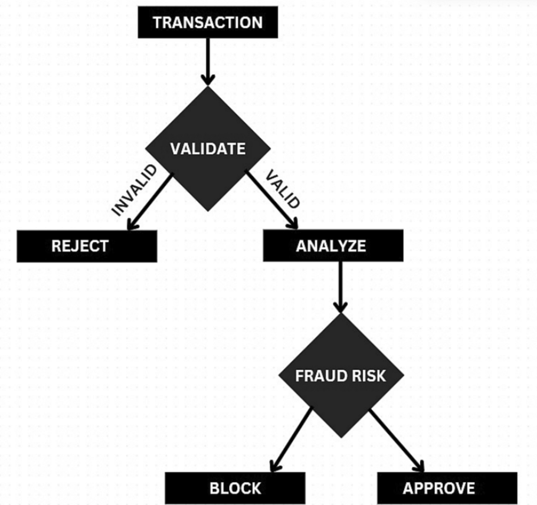
Figure 4.3. Fraud decision flow diagram from the supplied report.

5.2 Specific Objectives
- Load and prepare transaction features in the correct order.
- Use the trained Random Forest model to estimate fraud probability.
- Apply the threshold recorded in model metadata.
- Support both individual transaction entry and batch CSV prediction.
- Present classification, risk level, and decision guidance clearly.
- Expose prediction functionality through a REST API.
- Maintain a traceable record of predictions when SQLite logging is enabled.
- Provide basic analytics and data-drift monitoring support.
- Document setup and deployment using the project's requirements and Docker files.

5.3 Expected Outcomes
The expected outcome is a working demonstration in which a user can submit transaction data, inspect prediction results, process a batch, and access model inference through an API. Actual performance must be reported using measured results from the project's own notebook.

Chapter 6: Dataset and Feature Understanding

6.1 Introduction
The model uses the feature schema associated with the project's own credit-card transaction dataset. The precise source, row count, class counts, and split sizes should be verified against the actual CSV and notebook before publication.

6.2 Dataset Source
The notebook loads the ULB/Kaggle Credit Card Fraud Detection dataset from creditcard.csv. It checks missing values and duplicate rows, removes duplicates, and then performs exploratory analysis. The repository notebook's outputs are the source for the statistics reported in this chapter.
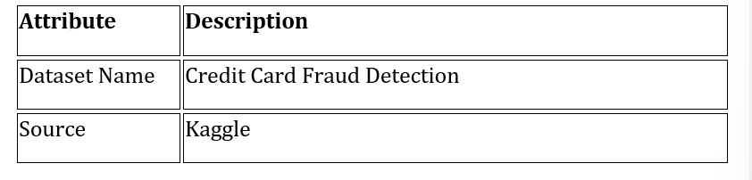
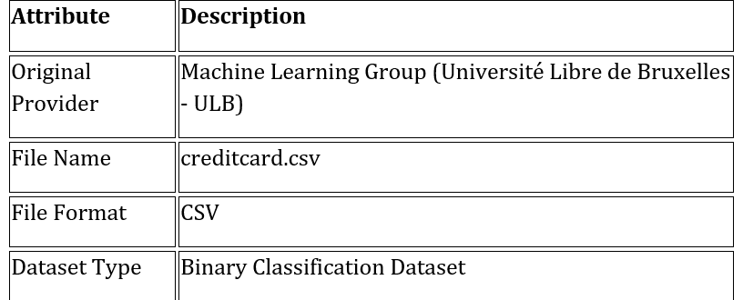

6.3 Dataset Characteristics
The input is tabular transaction data. The application expects numeric feature values compatible with the trained model and its preprocessing pipeline.
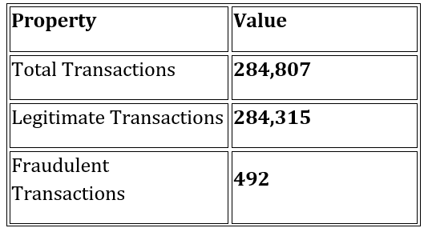

6.4 Dataset Features
The delivered application schema uses Time, Amount, and anonymized components V1 through V28, with Class serving as the label when labelled evaluation data is available. Class should not be supplied as a prediction feature.
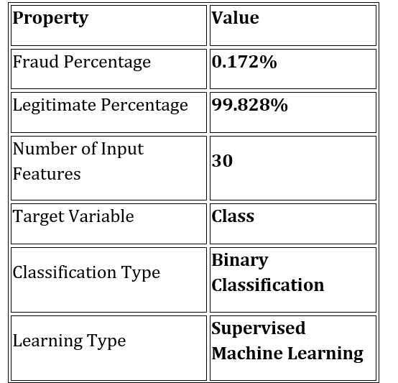

Feature | Description
Time | Time elapsed (in seconds) between the current transaction and the first transaction in the dataset
V1 – V28 | Numerical features obtained after Principal Component Analysis (PCA) transformation
Amount | Monetary value of the transaction
Class | Target variable (0 = Legitimate Transaction, 1 = Fraudulent Transaction)

6.5 Class Distribution
After removing 1,081 duplicate rows, the notebook contains 283,726 transactions: 283,253 legitimate transactions (Class 0; 99.8333%) and 473 fraudulent transactions (Class 1; 0.1667%). The notebook reported no missing values before duplicate removal. These are the notebook's cleaned-data counts; they should not be confused with the raw dataset counts before cleaning.
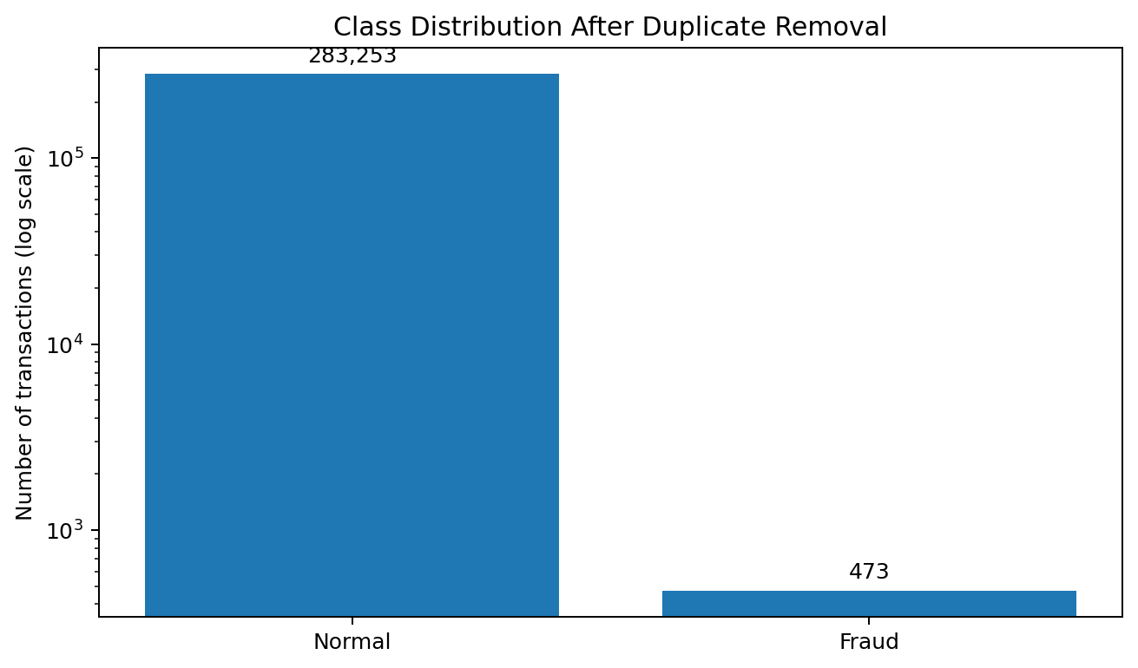
Figure 6.1. Class distribution in the cleaned notebook dataset (logarithmic y-axis makes the minority class visible).

6.6 Principal Component Analysis (PCA)
In datasets where V1–V28 are anonymized principal components, PCA has already transformed the original transaction attributes. The project should not claim to have independently performed PCA unless the notebook contains that step.

6.7 Challenges of the Dataset
- Potential class imbalance can make accuracy misleading.
- Anonymized features are difficult to interpret in business terms.
- Historical data may not represent future fraud patterns.
- Labels may be delayed or imperfect.
- The feature order and preprocessing must match the trained model.

6.8 Importance of the Dataset
A consistent labelled dataset allows the model to learn transaction patterns and enables evaluation using precision, recall, F1-score, ROC-AUC, PR-AUC, and confusion matrices.
- Real-world financial transaction data.
- A realistic class imbalance scenario.
- Numerical features suitable for machine learning.
- A standard benchmark for comparing different classification algorithms.
- A practical environment for evaluating ensemble learning methods.

Chapter 7: System Design and Workflow

7.1 Introduction
The project is designed as a small modular application. The model artifacts are separated from the dashboard and API so that inference can be reused by different interfaces.

7.2 Streamlit Dashboard
Streamlit provides the human-facing interface. A user can enter transaction values, upload a CSV, run predictions, review risk labels, inspect charts, and download batch results.

7.3 FastAPI Service
FastAPI exposes model functionality over HTTP. Clients submit structured transaction data and receive a machine-readable response. The interactive API documentation can be used to test endpoints during demonstration.

7.4 SQLite Audit Logging
SQLite provides a lightweight local database for recording prediction metadata, such as timestamp, source, probability, classification, risk level, and model version. It is useful for demonstration and traceability, but it is not a substitute for a hardened production audit platform.

7.5 Monitoring and Drift
Population Stability Index (PSI) can compare a reference feature distribution with a current distribution. PSI is a warning signal about input-data change, not proof that model accuracy has fallen. Drift alerts should trigger investigation.

7.6 Docker Configuration
Docker can package application code and dependencies into a container image. Environment-specific settings, persistent database storage, authentication, and secure network configuration still require attention before production use.

Chapter 8: Data Preparation

8.1 Introduction
The prediction pipeline must transform incoming values in the same way as the data used to train the model.

8.2 Input Validation
Inputs should contain the required feature names, use numeric values, and avoid missing or invalid values. Extra target labels such as Class should not be included in model input.

8.3 Feature Ordering
The feature columns must be arranged exactly as expected by the model metadata. A correct set of values in the wrong order can produce invalid predictions.

8.4 Scaling
The saved scaler is applied to the features for which it was fitted, such as Time and Amount if that matches the training notebook. The scaler must not be refitted on the user's test transaction.

8.5 Train, Validation, and Test Separation
Threshold selection and model selection should use validation data. The final test set should remain untouched until final evaluation to reduce optimistic performance estimates.

8.6 Chapter Summary
Consistent preprocessing, validation, and data separation are essential for trustworthy inference and evaluation.

Chapter 9: Machine Learning Methodology

9.1 Introduction
The system uses a supervised binary classifier trained from labelled transaction examples.

9.2 Random Forest Classifier
Random Forest is an ensemble method that trains multiple decision trees on sampled data and combines their outputs. It can model nonlinear relationships and interactions among features, while reducing some of the variance of a single tree.

9.3 Why Random Forest Was Used
Random Forest is a practical baseline for tabular classification, supports nonlinear decision boundaries, and provides feature-importance estimates. Its suitability must ultimately be judged by validation and test performance, latency, and operational needs.

9.4 Probability and Classification
The model's probability score is compared with a threshold. A score at or above the threshold is labelled as predicted fraud; a score below the threshold is labelled as predicted normal. The threshold is a decision setting, not a universal definition of fraud.

9.5 Class Imbalance Considerations
When fraud examples are rare, the model can achieve high accuracy by predicting most transactions as normal. Precision-recall metrics and the confusion matrix are therefore important.

9.6 Chapter Summary
The model is one component of the overall system; data preparation, threshold choice, interface design, logging, and monitoring are also necessary.

Chapter 10: Random Forest Implementation

10.1 Introduction
The trained Random Forest artifact is loaded by the application from the project's saved model file.

10.2 Loading the Model
The application loads the serialized model, preprocessing scaler, and metadata. If any required artifact is missing or incompatible, the application should stop with a clear error rather than produce an untrusted result.

10.3 Prediction Pipeline
- Receive a single transaction or a batch of transactions.
- Validate required columns and numeric values.
- Arrange features in the expected order.
- Apply the saved scaler to the appropriate columns.
- Call the model's probability prediction method.
- Apply the configured threshold and derive a result label.
- Display the result and optionally save an audit record.

10.4 Reproducibility
The model file, scaler, metadata, dependency versions, and training notebook should be kept together. The metadata should identify the model version and threshold used by the application.

Chapter 11: Model Configuration and Threshold

11.1 Introduction
A probability score must be converted into an operational decision. The threshold affects the balance between catching fraud and incorrectly flagging legitimate transactions.

11.2 Threshold Selection
A defensible workflow chooses the threshold using validation data and a documented business objective, such as meeting a target recall and then maximizing precision. The final test set should not be used to tune the threshold.

11.3 Project Threshold
The repository's model_metadata.json identifies the delivered application model as Random Forest and records a threshold of 0.14. Separately, the notebook's evaluation experiment selected a threshold of 0.02 for its Random Forest test probabilities to target recall of at least 80%. The report distinguishes the application setting from the notebook experiment rather than silently substituting one for the other.

11.4 Risk Level and Decision
The dashboard may map predicted probability to risk bands and a suggested action. These bands are application rules for demonstration and should be calibrated with domain experts before use in a financial institution.

11.5 Chapter Summary
Thresholds and risk bands are operational choices. They should be versioned, validated, and reviewed rather than treated as universal constants.

Chapter 12: Application Implementation

12.1 Introduction
The model is integrated into a dashboard and API so users can interact with the prediction system without running the notebook manually.

12.2 Single Transaction Prediction
A user enters the available transaction features and starts prediction. The application validates the inputs, prepares the feature vector, obtains the score, and displays the classification and risk information.

12.3 Batch CSV Prediction
The batch workflow accepts a CSV containing the required feature columns. It checks the schema, predicts each row, appends output fields such as probability and classification, and allows the user to download the results.

12.4 Streamlit Implementation
Streamlit handles forms, file upload, result cards, charts, tables, and downloadable outputs. It is the presentation layer for people using the application directly.

12.5 FastAPI Implementation
FastAPI provides endpoints for health checks and predictions. The API allows other programs to request predictions without operating the Streamlit interface.

12.6 SQLite Logging
Prediction records support review of what the application returned at a given time. Logs should avoid storing sensitive information unnecessarily and should be protected from unauthorized access.

12.7 Analytics Dashboard
Dashboard analytics can summarize the number of processed transactions, predicted fraud cases, risk distribution, and high-risk rows. These are summaries of model outputs, not verified fraud outcomes unless true labels are available.

12.8 Monitoring Implementation
A drift-monitoring script can compare reference and current feature distributions and report PSI values. A drift alert indicates a need to investigate data quality and model relevance.

12.9 Chapter Summary
The application wraps model inference in usable interfaces and adds supporting capabilities for batch processing, history, analytics, and monitoring.

Chapter 13: Evaluation and Performance Analysis

13.1 Introduction
Evaluation measures how well the classifier separates fraudulent and legitimate transactions on data that was not used for fitting or threshold selection.

13.2 Evaluation Metrics
- Accuracy: proportion of all predictions that are correct; it can be misleading on imbalanced data.
- Precision: proportion of predicted fraud cases that are actually fraud.
- Recall: proportion of actual fraud cases detected by the model.
- F1-score: harmonic mean of precision and recall.
- ROC-AUC: measures ranking discrimination across classification thresholds.
- PR-AUC: summarizes precision-recall trade-offs and is especially informative for rare positive classes.
- Confusion matrix: counts true positives, true negatives, false positives, and false negatives.

13.3 Performance Comparison
The following results are copied from the saved output of the project's own notebook. All models in this comparison use the same chronological test split and the default probability threshold of 0.50. Scores are rounded to four decimal places. The separate threshold-optimized Random Forest results are reported below and are not mixed with this default-threshold table.
See the inserted model-comparison figure and the detailed notebook results table in the Notebook Evidence section at the end of this report.

13.4 Comparative Analysis
A fair comparison uses the same data split and evaluation procedure for each model. If the delivered application uses Random Forest, its model artifact and reported test results should match.

13.5 Why Accuracy Alone Is Not Enough
If almost all transactions are legitimate, a model can appear highly accurate while missing many fraud cases. Recall and precision reveal this trade-off.

13.6 Importance of Precision and Recall
Higher recall can catch more fraudulent transactions but may increase false alarms. Higher precision reduces false alarms but can miss some fraud. The appropriate balance depends on review capacity and the cost of different errors.

13.7 False Positives and False Negatives
A false positive is a legitimate transaction flagged as fraud; a false negative is a fraudulent transaction missed by the model. Both matter, but their costs differ.

13.8 Practical Implications
A prediction should be interpreted as a risk estimate rather than proof of criminal activity. High-risk cases may require additional authentication or human review.

13.9 Discussion
The notebook sorts transactions by Time and uses a chronological 70/15/15 split: 198,608 rows for training, 42,559 for validation, and 42,559 for testing. The default-threshold comparison is evaluated on the test set. A separate threshold search then selects 0.02 for the Random Forest experiment to meet the notebook's target recall of at least 80%. The deployed application configuration in the repository metadata is separately recorded as Random Forest with threshold 0.14; these two values belong to different stages/configurations and must not be treated as interchangeable.

13.10 Chapter Summary
Performance claims should be traceable to reproducible evaluation output. The report does not invent metric values that are not verified in the project files.

Chapter 14: Limitations of the Study

14.1 Introduction
The project demonstrates a fraud detection workflow but has limitations that should be understood before practical use.

14.2 Highly Imbalanced Dataset
Rare fraud examples can make metrics unstable and may cause the model to favour the majority class.

14.3 Anonymized Dataset
Anonymized features limit direct explanation of why a specific transaction was flagged.

14.4 Historical Dataset
Past transaction patterns may not represent current fraud behaviour.

14.5 Limited Generalization
A model trained on one dataset may perform differently on another bank, region, time period, or customer population.

14.6 Dependence on Hyperparameter Selection
Model settings and threshold choices affect the precision-recall trade-off.

14.7 Computational Requirements
Training and batch processing costs depend on dataset size and machine resources.

14.8 Lack of Live Banking Integration
The prototype does not directly connect to a real payment processor or bank transaction stream.

14.9 Limited Feature Availability
Predictions depend on the availability and quality of the features expected by the model.

14.10 No Claim of Advanced Data Balancing
The report should describe balancing methods only if they were actually used in the training notebook.

14.11 Summary of Project Limitations
The application is a prototype and requires further validation, security review, and operational testing before deployment.

14.12 Chapter Summary
Limitations define the boundaries of the current implementation and guide future improvements.

Chapter 15: Findings and Conclusions

15.1 Introduction
This chapter summarizes the system and its demonstrated capabilities.

15.2 Summary of the Work
The project connects a trained Random Forest model to a Streamlit dashboard and FastAPI service, with support for batch analysis, metadata, optional SQLite logging, monitoring, and Docker configuration.

15.3 Major Findings
A complete fraud detection demonstration requires more than a fitted classifier; preprocessing consistency, threshold choice, clear outputs, and traceable configuration are also important.

15.4 Performance of the Machine Learning Model
The final model's performance must be stated using the verified results in the project's notebook and report. This document intentionally does not borrow metrics from the separate project.

15.5 Achievement of Project Objectives
The architecture supports single prediction and batch workflows, API-based inference, readable results, and a path toward audit logging and monitoring.

15.6 Practical Significance
The prototype demonstrates how machine learning can support transaction screening and analyst prioritization.

15.7 Final Conclusion
The project provides an end-to-end educational prototype for credit-card fraud prediction. Any real-world use would require stronger validation, security controls, human oversight, and continuous monitoring.

15.8 Chapter Summary
The work illustrates the integration of a model with the software components needed to present and operate its predictions.

Chapter 16: Future Scope and Recommendations

16.1 Introduction
The current prototype can be extended with more rigorous validation, stronger deployment controls, and improved monitoring.

16.2 Real-Time Fraud Detection
A future version could consume a secure transaction stream and return decisions within a defined latency target.

16.3 Larger and More Recent Datasets
Testing on more recent and diverse data would help assess robustness and changing fraud patterns.

16.4 Handling Class Imbalance
Class weights, resampling, cost-sensitive learning, and threshold tuning may be compared if justified by validation results.

16.5 Hyperparameter Optimization
Structured search and cross-validation can be used to improve model settings while preventing test-set leakage.

16.6 Deep Learning-Based Fraud Detection
Neural approaches could be explored where data volume, feature representation, and operational requirements justify their complexity.

16.7 Integration with Artificial Intelligence
Additional anomaly detection or graph-based signals may complement supervised predictions.

16.8 Cloud-Based Deployment
A cloud deployment could improve availability and scaling when paired with access control, monitoring, and secure configuration.

16.9 Web and Mobile Integration
Other client applications could call the API and present results in their own workflows.

16.10 Explainable AI
Feature attribution or local explanation tools could help analysts understand model behaviour, while recognizing that explanations are not causal proof.

16.11 Continuous Model Updating
Retraining should be triggered by evidence, reviewed labels, and validation—not automatically from unverified predictions.

16.12 Future Research Opportunities
Further work could evaluate cost-sensitive metrics, fairness, calibration, adversarial robustness, and drift-response policies.

16.13 Poster Presentation
A poster can show the problem, dataset schema, architecture, verified evaluation metrics, dashboard screenshots, and limitations.

16.14 Chapter Summary
Future work should prioritize validated performance, responsible decision support, secure deployment, and measurable monitoring.

Chapter 17: Project Reflection and Evaluation

17.1 Introduction
The project combines data science and software engineering in a practical prototype.

17.2 Project Accomplishments
The work demonstrates how a saved model can be integrated with a dashboard and API, and how batch predictions and operational supporting components can be organized.

17.3 Knowledge Gained
The project provides experience with data preprocessing, classification metrics, probability thresholds, dashboard development, REST APIs, database logging, and deployment concepts.

17.4 Industrial Relevance
Fraud screening systems use model scores to prioritize review and support risk decisions. Real deployments require rigorous governance, secure data handling, and human escalation paths.

17.5 Overall Project Evaluation
The project should be evaluated against reproducibility, correctness of preprocessing, model metrics, usability, error handling, and clarity of documentation.

17.6 Internship Experience
During my internship, I gained valuable knowledge and practical exposure to the field of machine learning and its applications in fraud detection. As a student of Class 12th, Science, this project provided me with an opportunity to explore concepts beyond my regular academic curriculum and understand how technology can be used to solve real-world problems.
Through the Credit Card Fraud Detection project, I learned about the basic workflow of a machine learning application, including understanding the dataset, preparing data, training a model, evaluating its performance, and integrating the model into an application workflow. I also developed a better understanding of why detecting fraudulent transactions is important for financial security and why machine learning can be useful in identifying suspicious patterns in transaction data.
This internship experience helped me improve my analytical thinking, problem-solving ability, and understanding of technical concepts. It also taught me the importance of organizing project work, documenting the implementation process, and presenting results clearly. Overall, the experience encouraged me to explore computer science, artificial intelligence, and machine learning in greater depth.

17.7 Acknowledgement of Guidance
I would like to express my sincere gratitude to Dr. Debaditya Barman, Assistant Professor, Department of Computer and System Sciences, Visva-Bharati University, West Bengal, India, for his valuable guidance and academic support during this project.
His guidance helped me understand the subject more clearly and approach the project in a systematic manner. The opportunity to work on a machine learning-based Credit Card Fraud Detection project allowed me to learn about the practical application of concepts related to data analysis, model development, and evaluation.
I am grateful for the academic direction and encouragement that supported my learning throughout this work. This project has been an important learning experience for me, and I appreciate the opportunity to develop my technical knowledge and gain a better understanding of how machine learning techniques can be applied to practical problems.

17.8 Final Remarks
The Credit Card Fraud Detection project has been an important step in my learning journey. It helped me understand how machine learning techniques can be applied to a practical problem involving financial transactions and the identification of potentially fraudulent activities.
Through this project, I explored the stages involved in developing a machine learning application, from working with transaction data to training and evaluating a model. I also learned that building a useful machine learning system requires more than simply training a model. Data quality, appropriate evaluation methods, application integration, and clear communication of results are also important.
This project should be considered a learning-oriented implementation rather than a fully deployed, real-world fraud detection system. Its effectiveness depends on the dataset, the selected model, the evaluation process, and the limitations of the implementation. Further improvements could include testing on more diverse transaction data, comparing additional machine learning algorithms, improving the handling of imbalanced classes, and evaluating the model under realistic conditions.
In conclusion, the project strengthened my interest in technology and machine learning while helping me recognize both the potential and the limitations of data-driven systems.

17.9 Chapter Summary
This chapter summarizes the overall learning outcomes and practical understanding I gained through the Credit Card Fraud Detection project. The work introduced me to the process of transforming a machine learning model into an application workflow that can accept transaction-related input and produce a prediction.
I gained an understanding of the relationship between data preparation, model training, performance evaluation, and application development. I also learned why the results produced by a model must be interpreted carefully and why a prediction should not automatically be treated as definitive proof of fraud.
The project provided me with valuable exposure to problem-solving, technical documentation, and the structured development of a machine learning application. It also helped me identify areas where further learning and experimentation would be beneficial.
Overall, this project connected theoretical concepts with practical implementation and gave me a foundation for exploring more advanced topics in computer science, artificial intelligence, and machine learning in the future.

Chapter 18: References
The following books, research papers, documentation, and online resources were referred to during the development of this project.
Books
[1] T. Hastie, R. Tibshirani, and J. Friedman, The Elements of Statistical Learning: Data Mining, Inference, and Prediction, 2nd ed. New York, NY, USA: Springer, 2009.
[2] C. M. Bishop, Pattern Recognition and Machine Learning. New York, NY, USA: Springer, 2006.
[3] A. Géron, Hands-On Machine Learning with Scikit-Learn, Keras & TensorFlow, 3rd ed. Sebastopol, CA, USA: O'Reilly Media, 2022.
[4] E. Alpaydin, Introduction to Machine Learning, 4th ed. Cambridge, MA, USA: MIT Press, 2020.

Research Papers
[5] L. Breiman, "Random Forests," Machine Learning, vol. 45, no. 1, pp. 5–32, 2001.
[6] Y. Freund and R. E. Schapire, "A Decision-Theoretic Generalization of On-Line Learning and an Application to Boosting," Journal of Computer and System Sciences, vol. 55, no. 1, pp. 119–139, 1997.
[7] T. Chen and C. Gastrin, "XGBoost: A Scalable Tree Boosting System," in Proceedings of the 22nd ACM SIGKDD International Conference on Knowledge Discovery and Data Mining (KDD), 2016, pp. 785–794.
[8] G. Ke et al., "LightGBM: A Highly Efficient Gradient Boosting Decision Tree," in Advances in Neural Information Processing Systems (Nauris), 2017.
[9] L. Prokopenko, G. Gusev, A. Vorobev, A. V. Doro gush, and A. Gulin, "CatBoost: Unbiased Boosting with Categorical Features," in Advances in Neural Information Processing Systems (Nauris), 2018.

- Scikit-learn documentation, RandomForestClassifier and classification metrics: https://scikit-learn.org/stable/
- Streamlit documentation: https://docs.streamlit.io/
- FastAPI documentation: https://fastapi.tiangolo.com/
- SQLite documentation: https://www.sqlite.org/docs.html
- Docker documentation: https://docs.docker.com/
- Dataset reference: cite the exact dataset page and version actually used by the project; verify the source before final submission.
- Project-specific evidence: the project's own notebook, README, model metadata, and evaluation output.

Notebook Evidence: Actual Dataset and Evaluation Results
This section records the outputs visible in the project's GitHub notebook, Credit_Card_Fraud_Detection_Production_Ready (1).ipynb. It is kept separate from the deployed application configuration because the notebook contains an experimental model comparison and threshold search, while the repository metadata defines the application model and threshold.

A. Dataset cleaning and class distribution
The notebook reported 284,807 rows and 31 columns at load time, zero missing values, and 1,081 duplicate rows. After duplicate removal, the dataset had 283,726 rows and 31 columns. The cleaned class distribution was 283,253 normal transactions (99.8333%) and 473 fraud transactions (0.1667%).
Figure N.1. Class distribution after duplicate removal. Counts and percentages are from the notebook output.

B. Chronological data split
The notebook sorts by Time before splitting the cleaned data into 70% training (198,608 rows), 15% validation (42,559 rows), and 15% test (42,559 rows). The test set contained 52 fraud cases, as shown in the classification report.

C. Model comparison at threshold 0.50
The table below reproduces the notebook's model-comparison output. PR-AUC is useful for a highly imbalanced fraud dataset because it summarizes precision and recall over thresholds. The Neural Network optimizer rows refer to the same network design trained with different optimizers.
Model | Accuracy | Precision | Recall | F1 | ROC-AUC | PR-AUC
Neural Network – RMSprop | 0.9973 | 0.2837 | 0.7692 | 0.4145 | 0.9824 | 0.7721
Random Forest | 0.9996 | 0.9730 | 0.6923 | 0.8090 | 0.9363 | 0.7712
XGBoost | 0.9996 | 0.8667 | 0.7500 | 0.8041 | 0.9777 | 0.7694
CatBoost | 0.9995 | 0.8125 | 0.7500 | 0.7800 | 0.9589 | 0.7645
Neural Network – Adam | 0.9936 | 0.1349 | 0.7885 | 0.2303 | 0.9849 | 0.7620
Logistic Regression – SAGA | 0.9827 | 0.0568 | 0.8462 | 0.1065 | 0.9787 | 0.7430
Logistic Regression – LBFGS | 0.9824 | 0.0560 | 0.8462 | 0.1050 | 0.9775 | 0.7102
Neural Network – SGD | 0.9928 | 0.1235 | 0.8077 | 0.2143 | 0.9706 | 0.6945

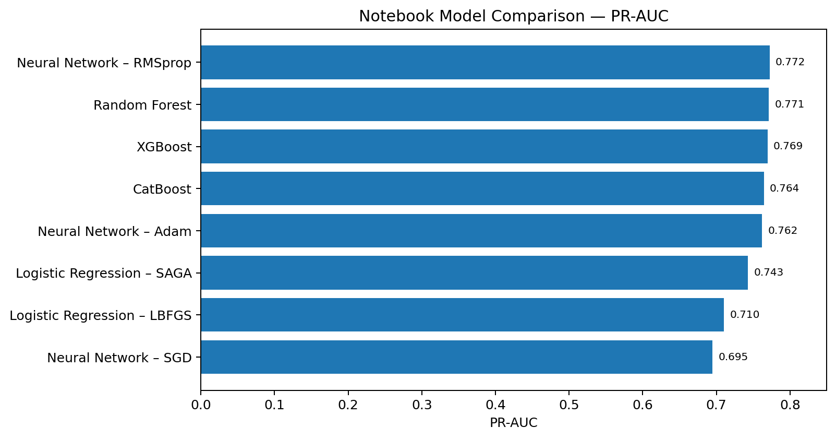
Figure N.2. PR-AUC comparison from the notebook's reported test metrics.

D. Random Forest threshold optimization
At the default threshold of 0.50, the notebook reports Random Forest precision 0.9730, recall 0.6923, F1-score 0.8090, ROC-AUC 0.9363, and PR-AUC 0.7712. The threshold search chose 0.02 to achieve recall of at least 0.80, resulting in precision 0.2308, recall 0.8077, and F1-score 0.3590. This illustrates the trade-off: more fraud cases are detected, but more legitimate transactions are flagged.
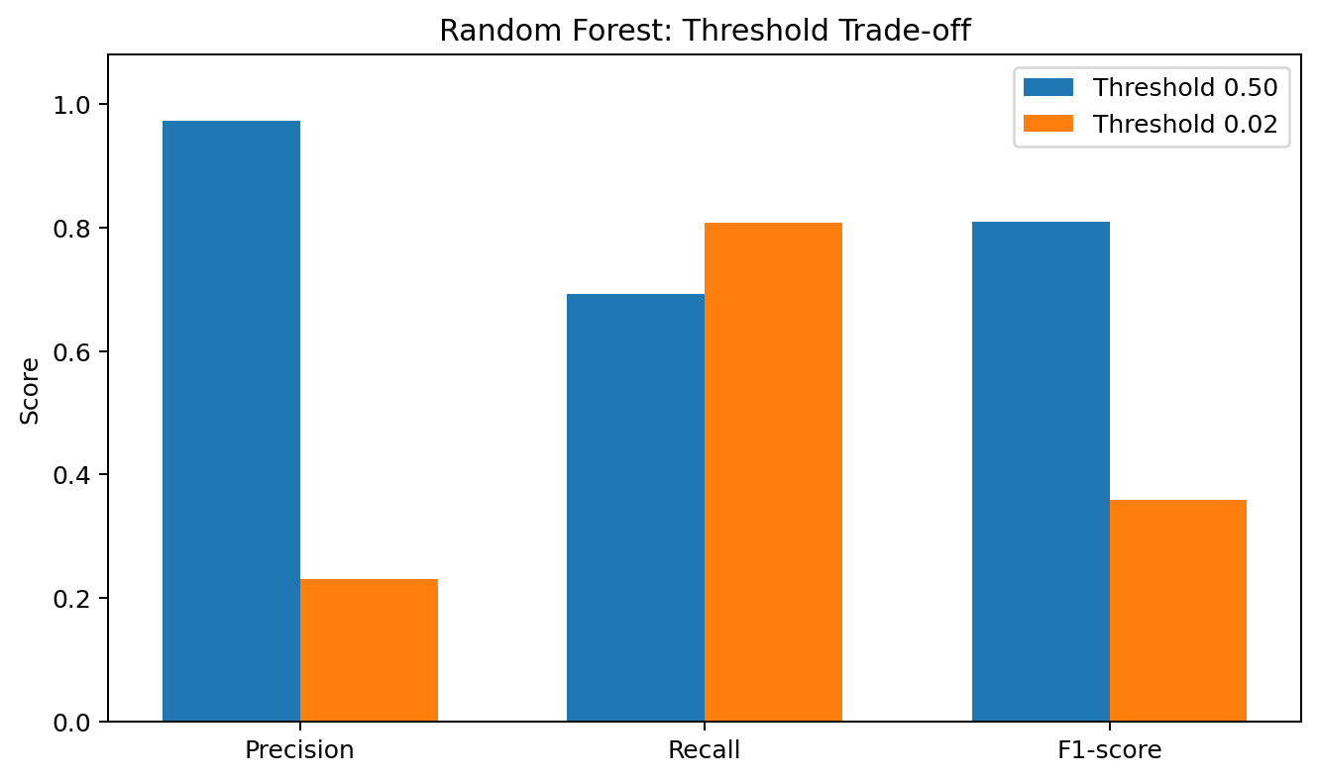
Figure N.3. Precision, recall, and F1-score at the two Random Forest thresholds.
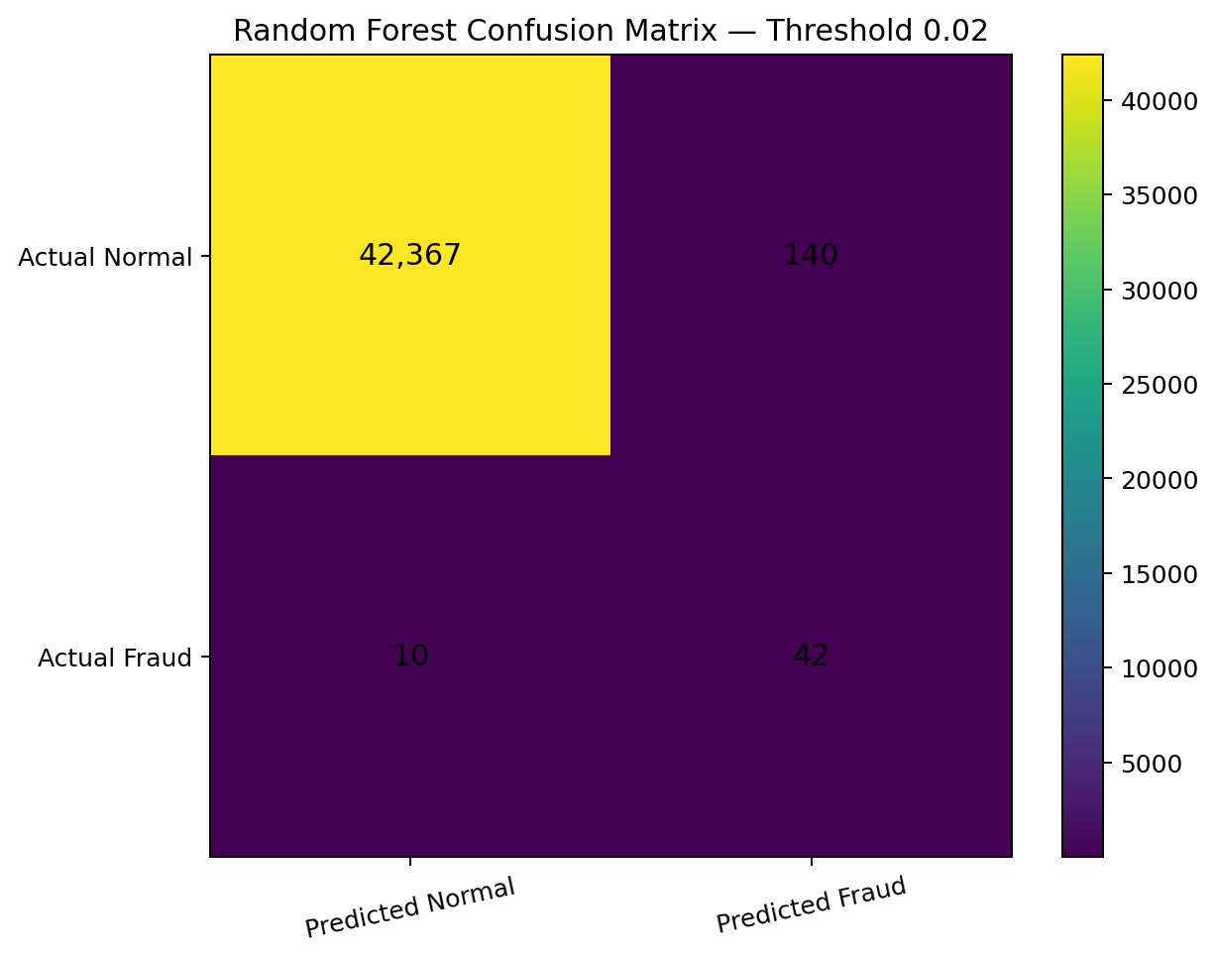
Figure N.4. Confusion matrix reconstructed from the notebook's reported test support, precision, and recall at threshold 0.02: TN=42,367, FP=140, FN=10, TP=42.

E. Random Forest feature importance
The notebook's Random Forest feature-importance output lists V14, V10, V4, V12, and V17 as the five highest-ranked features. These are model-derived importance values, not proof that the features cause fraud.
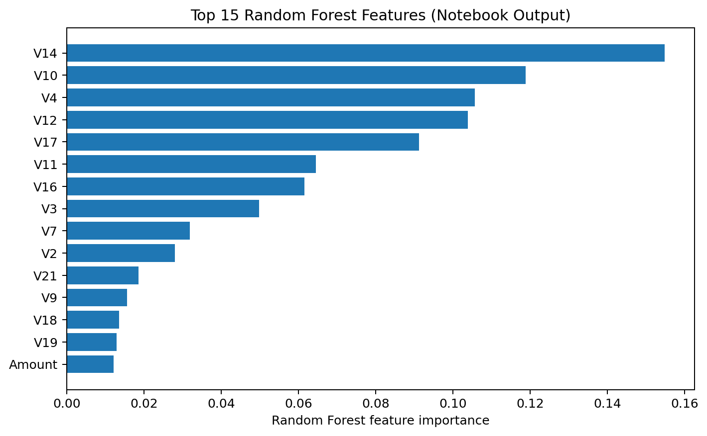
Figure N.5. Top 15 Random Forest features reported by the notebook.

F. Important implementation distinction
The notebook's experimental comparison and threshold-search cells contain multiple models, including Logistic Regression, Random Forest, XGBoost, CatBoost, and neural networks with Adam, RMSprop, and SGD. The repository's delivered application metadata separately names Random Forest and sets threshold 0.14. The report therefore presents the notebook's comparison results as experimental evidence and the repository metadata as the delivered app configuration. It does not claim that the app uses the notebook's 0.02 threshold.

Conclusion
In conclusion, the Credit Card Fraud Detection project helped me understand how machine learning can be used to identify potentially fraudulent credit card transactions. I learned how Python, Pandas, NumPy, and Scikit-learn support data processing and model development, while Streamlit provides a user-friendly frontend dashboard and FastAPI handles backend prediction requests. SQLite can be used to maintain prediction history.
This project helped me gain practical knowledge of machine learning, application development, and the integration of frontend and backend components. It also improved my problem-solving skills and understanding of how theoretical concepts can be applied to real-world problems.
Although this project is an educational prototype and is not connected to a real banking system, it provides a useful foundation for further learning. In the future, the system could be improved by testing additional machine learning models, evaluating performance on more diverse datasets, and strengthening its security and reliability.
Overall, this project was a valuable learning experience for me as a Class 12 Science student. It increased my interest in computer science, artificial intelligence, and machine learning and encouraged me to explore these fields further.

TITLE: CREDIT CARD FRAUD DETECTION
USING MACHINE LEARNING

SUPERVISOR
DR. DEBADITYA BARMAN
Assistant Professor
Department of Computer and System Science
Visva-Bharati University, West Bengal, India.

Submitted by
JEMIMA HOSSAIN
INTERNSHIP PROJECT
2026

Submitted to
VISVA-BHARATI UNIVERSITY, WEST BENGAL, INDIA.

ACKNOWLEDGEMENT

I am very grateful to my supervisor respected Dr. Debaditya Barman, Assistant professor, Department of Computer and System Science, Visva-Bharati University, West Bengal, India, under whose supervision and guidance, this research project work for internship has been completed. He helped me a lot and guided me thoroughly with his vast teaching and research experience to complete this project work for my internship. His valuable guidance, advice and encouragement were invaluable in bringing this internship project work “Credit Card Fraud Detection using Machine Learning” to the reality.
I am also very much grateful to the most respected Head of the Department Sir, the Department of Computer and system Science, Visva-Bharati University, West Bengal, India for giving me the permission for my internship on the topic online “Credit Card Farud Detection”.
I am also thankful to my parents for their continuous support and encouragement to reach the goal. I am also thankful to my teachers for giving me inspiration for doing this internship from the Visva-Bharati University.

Jemima Hossain.

DECLARATION

I, Jemima Hossain, do hereby certify that I have personally carried out the internship project work depicted in the internship in the project entitled, “Credit Card Fraud Detection Using Machine Learning”.
No part of this internship project has been submitted for the award of any certificate, diploma or degree prior to this date.

Date: Signature

(Jemima Hossain)

